
ADHIYAMAAN COLLEGE OF ENGINEERING
[AUTONOMUS]
ADVANCED FEATURE ENGINEERING IN PARKINSON’S
DISEASE DETECTION USING MACHINE LEARNING ALGORITHMS
DOMAIN:MACHINE LEARNING
BATCH MEMBERS:  SUBASHREE S [6176AC21UEC124]  SUSHMITHAK[6176AC21UEC129]  THEJA S[6176AC21UEC140]  VYSHNAVI P[6176AC21UEC162] | INTERNAL SUPERVISOR:  Dr. S SUMATHI  PROFESSOR AND  HEAD/ECE  ACE,HOSUR
DEPARTMENT OF ECE

CONTENTS
- INTRODUCTION -----------------------------------------------------------3
- OBJECTIVE -----------------------------------------------------------------4
- ABSTRACT -----------------------------------------------------------------5
- LITERATURE SURVEY --------------------------------------------------6
- DESIGN AND IMPEMENTION -----------------------------------------7
- EXISTING SYSTEM ------------------------------------------------------8
- PROPOSED SYSTEM -----------------------------------------------------9
- ALGORITHM---------------------------------------------------------------10
- ADVANTAGES ------------------------------------------------------------15
10) DISADVANTAGES------------------------------------------------------16
11) GANTT CHART----------------------------------------------------------17
12) REFERENCES------------------------------------------------------------18

INTRODUCTION
- Parkinson's Disease (PD) is a progressive neurological disorder that primarily affects movement, causing symptoms such as tremors, stiffness, and balance problems.
- Early detection is crucial for managing the disease effectively, as timely intervention can significantly improve the quality of life for patients.
- Traditional diagnostic methods often rely on clinical evaluations, which can be subjective and may not detect early-stage symptoms.
- Recent advancements in machine learning (ML) offer promising avenues for enhancing the accuracy and speed of Parkinson's disease detection.
- By analyzing large datasets that include patient demographics, clinical assessments, and neuroimaging data, machine learning algorithms can identify patterns that may be indicative of PD.

OBJECTIVE
- Data Collection and Preprocessing: Gather and preprocess relevant datasets containing features indicative of Parkinson's disease, such as tremor measurements, gait patterns, and voice recordings.
- Feature Selection: Identify and select the most significant features that contribute to the classification of Parkinson's disease to improve model performance and reduce complexity.
- Model Development: Develop various machine learning models (e.g., support vector machines, decision trees, and neural networks) to classify individuals with and without Parkinson's disease.
- Real-time Detection: Explore the potential for implementing real-time monitoring solutions using wearable devices to facilitate continuous assessment of patients.
- Future Research Directions: Identify areas for future research, including integration with other diagnostic tools and enhancements in model accuracy and reliability.

ABSTRACT

This study explores advanced feature engineering techniques to enhance the performance of machine learning (ML) algorithms in PD detection. By leveraging signal processing, statistical transformations, and dimensionality reduction techniques, we extract meaningful features from biomedical voice and movement datasets. Various ML models, including Support Vector Machines (SVM), Random Forest (RF), and Deep Learning approaches, are trained and evaluated. Experimental results demonstrate that optimized feature selection significantly improves classification accuracy, sensitivity, and specificity. This work highlights the critical role of feature engineering in refining PD diagnosis through ML-driven approaches.

LITERATURE SURVEY
S.No | YEAR | TITLE | REFERENCE
1 | 2018 | Parkinsons disease assist device using machine learning and IOT | Shivangi, Anubhav Johri and Ashish Tripathi Department of Computer Science Jaypee Institute of Information  Technology,2018
2 | 2018 | A deep learning approach for parkinsons disease diagnosis from EEG signals | Aarushi Agarwal, Spriha  Chandrayan and Sitanshu S Sahu Department of Electronics and Communication  Engineering Birla Institute of Technology, Mesra, Ranchi,  India,2018

DESIGN AND IMPEMENTION
Data Gathering: The first step is data gathering. This step is very important because the quality and quantity of the data you gather will directly affects the level of your prediction model. Data Preparation: In this step data is visualized well to spot the relationship between the parameters present in the data so as to take the advantage of as well as to get the data.
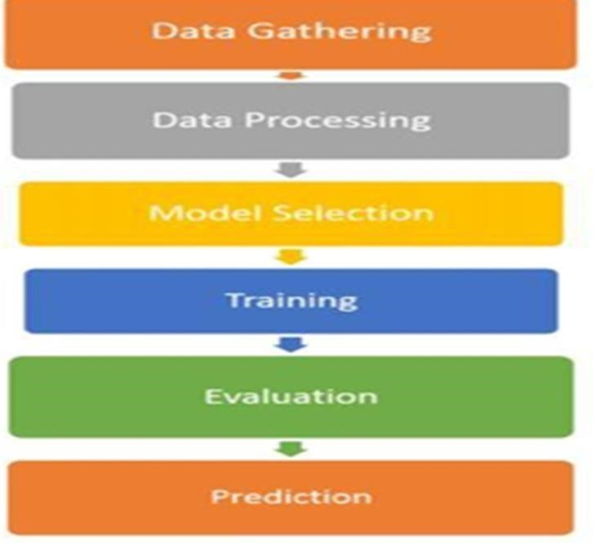
Model Selection: In this model selection there are various model is used to till date by research and scientist. Some are meant by image processing, some for sequences like text, numbers or patterns.
Training: Training the dataset is the main task of machine learning. We will apply the data to progressively improve the selected model to predict the better actual result should be approx. to predict one.
Evaluation: The metrics we have calculated are ROC, Accuracy , Specificity , Precision etc. which will highlights the best algorithm among all.
Prediction: In this phase we finally get the model ready to detect the prediction of Parkinson’s disease based on the given dataset.

EXISTING SYSTEM
- Wearable Devices:Devices such as smartwatches and fitness trackers collect movement data (e.g., tremors, gait) and monitor physical activity.
- Mobile Health Apps:Applications that allow patients to log symptoms, perform motor tasks, and track their health over time.
- Voice and Speech Analysis Tools:Systems that analyze voice characteristics (e.g., pitch, tone, speech rate) to detect changes associated with Parkinson’s.
- Computer Vision Systems:Use video analysis to evaluate motor symptoms by tracking movements and

PROPOSED SYSTEM
The proposed system focuses on leveraging advanced feature engineering techniques to enhance the detection accuracy of Parkinson’s Disease using machine learning algorithms. The system consists of several key components:
- Data Acquisition and Preprocessing: Collecting relevant datasets and cleaning data for consistency and accuracy.
- Feature Engineering: Extracting and selecting the most relevant features using statistical, frequency-domain, and deep learning-based methods.
- Model Implementation: Utilizing various machine learning models such as Random Forest, SVM, and deep learning models to classify PD and non-PD cases.
- Optimization and Evaluation: Applying hyperparameter tuning, crossvalidation, and model evaluation metrics to refine the system.
- Deployment: Deploying the trained models into real-world applications using API integration and cloud-based platforms for real-time analysis.

ALGORITHM
Extreme gradient boosting (XGBoost):
• The XGBoost was proposed as an alternative method to predict a response variable given certain covariates.It uses a gradient boosting framework and is also a decision-tree-based ensemble method. The core principle of this method is that it builds classification or regression trees one by one, and then the residuals of the previous tree are used to train the subsequent model. In the training process, this method can integrate values of the previously trained trees to achieve a better outcome. It can use the pruning procedure to avoid overfitting, which reduces the size of a decision tree by removing decision nodes that contribute little to target values.
The prediction is calculated as:
yˆit=∑k=1tfk(xi)=yˆi(t−1)+ft(xi) where yˆit denotes the final tree model; yˆi(t−1) is the previous tree model; ft(xi) is the newly generated tree model, and t is the total number of base tree models. To achieve optimal model performance, it is important to select appropriate values of depth and number of trees. The objective function is defined as:
Objt=∑i=1tL(yi,yˆit)+∑i=1tΩ(fi)
where yi is the actual value; yˆit is the predicted value; L(yi,yˆit) is the loss function and Ω(fi) is the regularization term.
Substituting the above equations some detection steps can be obtained as:
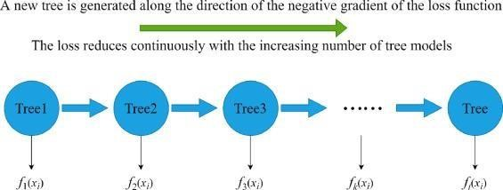
Objt=∑i=1tL(yi,yˆi(t−1)+ft(xi))+Ω(ft)+constant
Following Chen and Guestrin , the objective function can be transformed into the form of the following equation:
Objt=∑i=1tgift(xi)+12hift2(xi)+Ω(ft) where
gi=∂yi(t−1)L(yi,yi(t−1)) and hi=∂2yi(t−1)L(yi,yi(t−1)) are the first and second-order gradient statistics on the loss function.
The regularization term Ω(ft) is expressed by above equation and it is used to reduce model complexity and avoid over-fitting, enhancing the generalization ability.
Ω(ft)=γT+12λ‖w‖2
where T is the number of leaves; w is the corresponding weights of the leaf; λ and γ are coefficients, and the default values are 1 and 0, respectively.
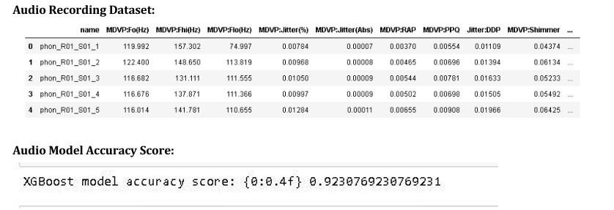
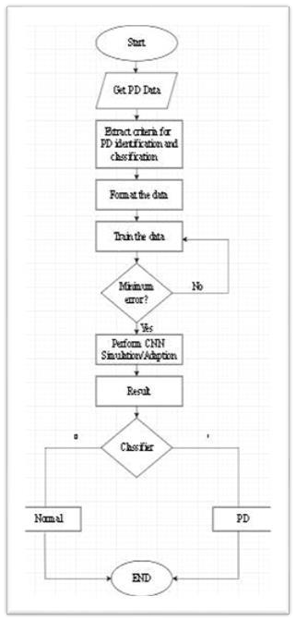
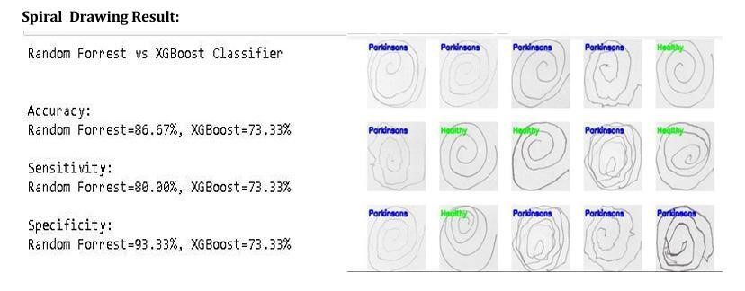
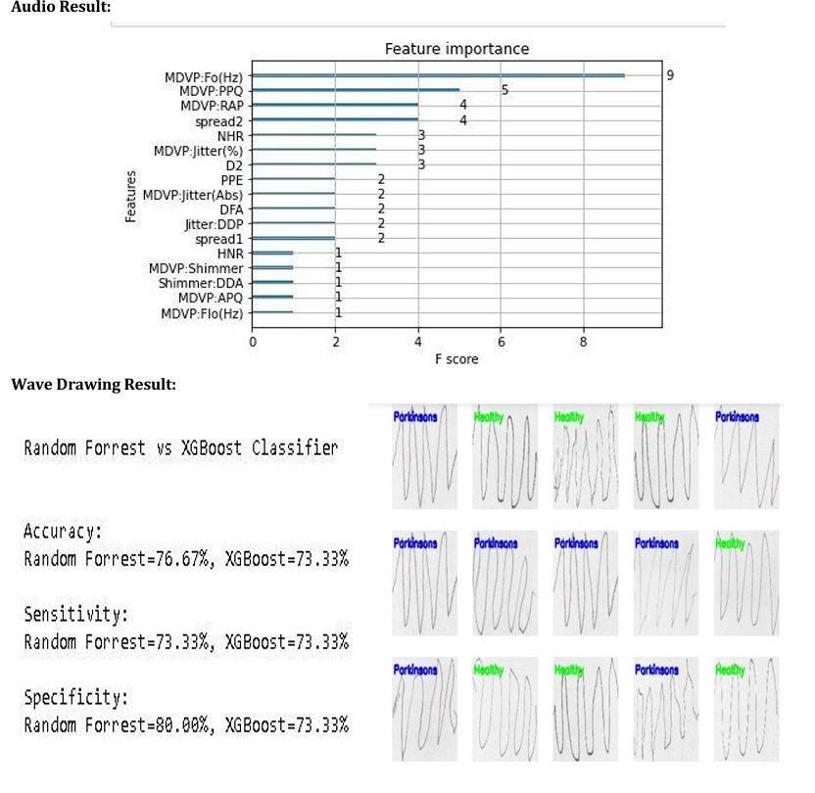

ADVANTAGES
1>Early Detection:Machine learning models can identify at-risk individuals before clinical symptoms appear, allowing for timely intervention.
2>Data-Driven Insights:These models can analyze large datasets to uncover complex patterns and relationships that may not be obvious through traditional methods.
3>Scalability:Once developed, machine learning models can be applied to large populations, making it feasible to screen many individuals efficiently.
4>Personalization:Predictions can be tailored to individual patients based on specific risk factors, leading to more personalized healthcare approaches.
5>Continuous Improvement:The models can be updated and improved as new data becomes available, enhancing their predictive accuracy over time.
6>Resource Optimization:By identifying high-risk patients, healthcare resources can be allocated more effectively, focusing efforts on those who need it most.

DISADVANTAGES
1>Data Quality and Availability:The accuracy of machine learning models relies heavily on the quality and comprehensiveness of the data. Incomplete or biased datasets can lead to poor predictions.
2>Interpretability:Some machine learning models, especially complex ones like deep learning, can be difficult to interpret, making it challenging for clinicians to understand how predictions are made.
3>Overfitting:There's a risk of models being too tailored to the training data, leading to poor performance on new, unseen data.
4>Ethical Concerns:Predictions may lead to anxiety or discrimination against individuals identified as high-risk, raising ethical considerations regarding privacy and consent.
5>Implementation Challenges:Integrating machine learning tools into clinical workflows may require additional training for healthcare professionals and adjustments in existing processes.

GANTT CHART


ACTIVITIES

TIMES IN WEEK

1

2

3

4

5

6

7

8

9

10

11

12

Preliminary

investigation

Data analysis

Circuit Analysis

Application(Flask)

development

Testing

Purchase of

Components

Final Result

Evaluation

of report

Final report

REFERENCES
[1] REFERENCES Shivangi, Anubhav Johri and Ashish Tripathi Department of
Computer Science Jaypee Institute of Information Technology 978-1-728135915/19/$31.00 ©2019 IEEE “Parkinson Disease Detection Using Deep Neural Networks”.
[2]Aarushi Agarwal, Spriha Chandrayan and Sitanshu S Sahu Department of
Electronics and Communication Engineering Birla Institute of Technology, Mesra, Ranchi, India 978-1-5386-5163 6/18/$31.00 ©2018 IEEE “Prediction of Parkinson’s Disease using Speech Signal with Extreme Learning Machine.
[3]Enes Celik Department of Computer Science Kirklareli University Kirklareli, Turkey 978-1-7281-1013 4/19/$31.00 ©2019 IEEE “Improving Parkinson’s Disease Diagnosis with Machine Learning Methods”.

THANK YOU

